Recursion

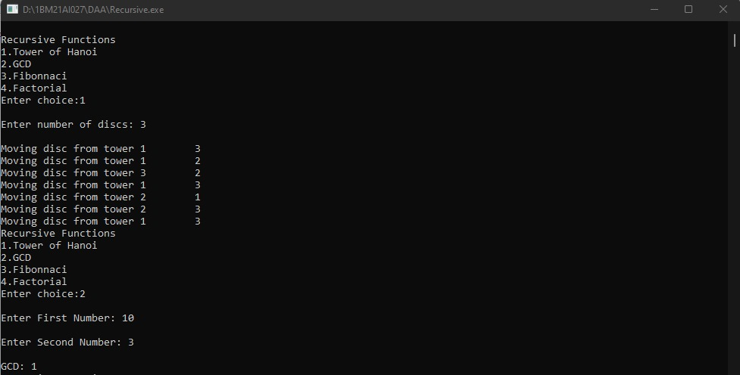

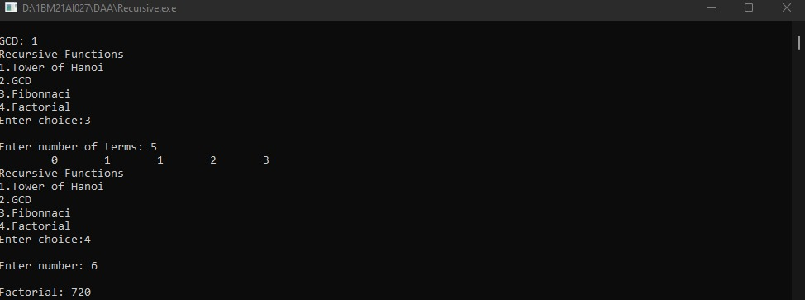

Search

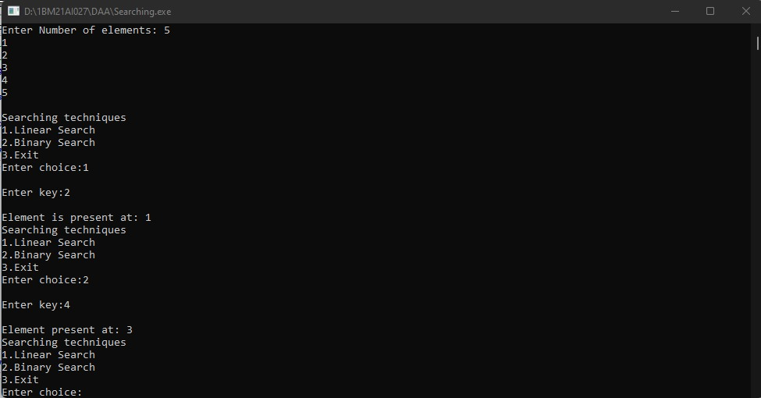

Selection

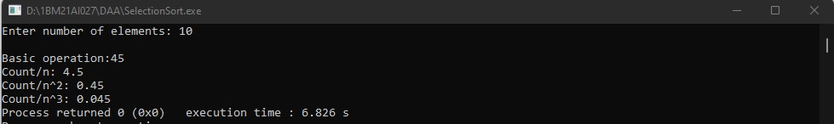

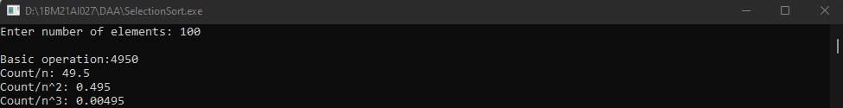

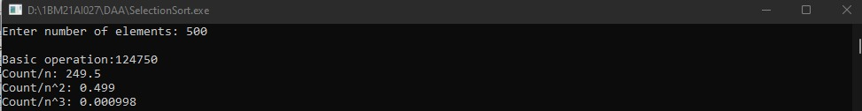

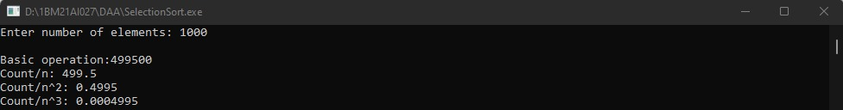

Bubble

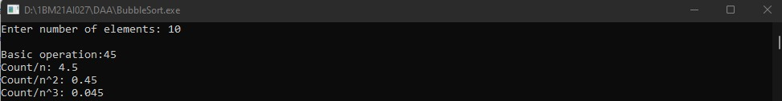

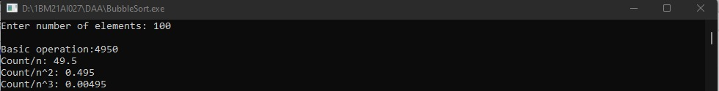

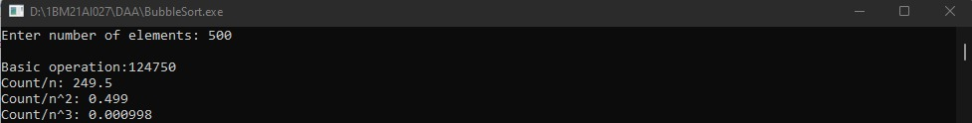

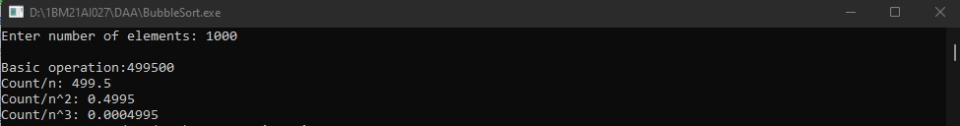

SELECTION AND BUBBLE SORT TABLE

|  |  |  |  |
| --- | --- | --- | --- |
| **n** | **Count/n** | **Count/n2** | **Count/n3** |
| 10 | 4.5 | 0.45 | 0.045 |
| 100 | 49.5 | 0.495 | 0.00495 |
| 500 | 249.5 | 0.499 | 0.000998 |
| 1000 | 499.5 | 0.4995 | 0.0004995 |

SELECTION AND BUBBLE SORT GRAPH

Merge

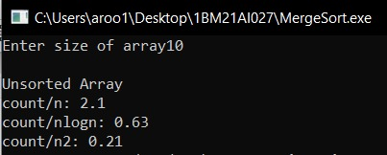

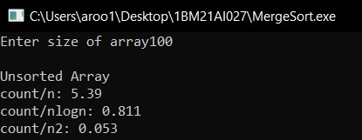

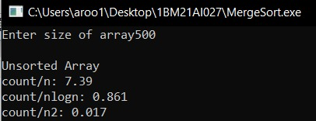

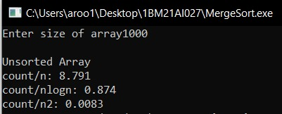

MERGE SORT TABLE

|  |  |  |  |
| --- | --- | --- | --- |
| **n** | **Count/n** | **Count/n2** | **Count/nlogn** |
| 10 | 2.1 | 0.21 | 0.63 |
| 100 | 5.39 | 0.053 | 0.811 |
| 500 | 7.71 | 0.015 | 0.860 |
| 1000 | 8.721 | 0.0087 | 0.875 |

MERGE SORT GRAPH

Quick

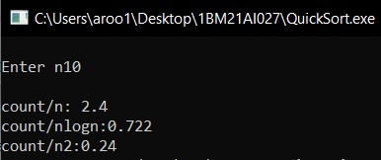 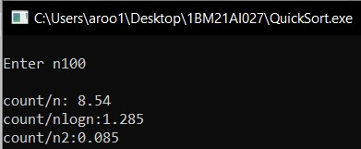

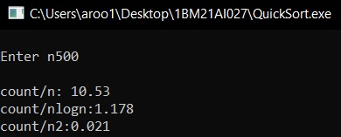

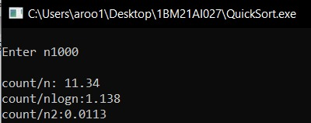

QUICK SORT TABLE

|  |  |  |  |
| --- | --- | --- | --- |
| **n** | **Count/n** | **Count/n2** | **Count/nlogn** |
| 10 | 2.4 | 0.24 | 0.722 |
| 100 | 8.54 | 0.085 | 1.285 |
| 500 | 10.504 | 0.021 | 1.171 |
| 1000 | 11.33 | 0.0113 | 1.138 |

QUICK SORT GRAPH